Andrea McGovern

Kayla Schmitt

**Final Project Report**

Our final project idea was to create an easy, nostalgic game that would appeal to all. We came up with the idea if a space themed shooting game called “Galaxy Shooters” using C# and Unity tools. Unity helped to aid in the creation and rendering of animation for characters, shooting, and the illusion of flying through space. We decided the main goal of this game would be to shoot a laser out of a space ship, hit good or bad targets, gain points for hitting good targets, and lose a life for hitting a bad target. You are given 3 lives throughout the game, and once you use them all the game is over. This simplistic game would be easy for people of all ages, and varying degree of gaming enjoyment.

To begin our project, we first decided we needed to tackle the concept and understanding of the game engine Unity. Neither of us have ever programmed in C# or worked with Unity so there was a large learning curve. We watched many YouTube tutorials that helped us learn how to use Unity. Our next step was to learn how to shoot targets and add a score. This is what our original game looked like with the cube as the shooter and the sphere and cylinder as the targets.

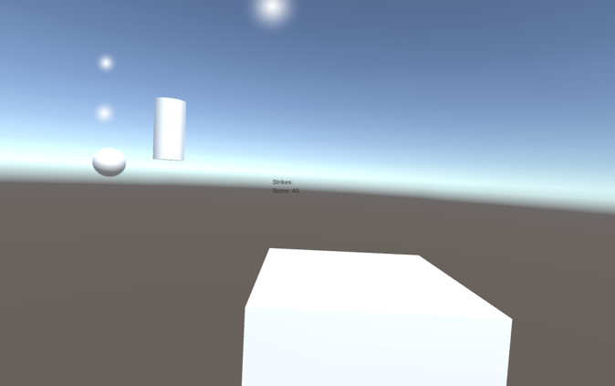

Once we learned how to create a simple shooting mechanism, our next step was to create the space universe. We used many of the provided assets in the space package of the Unity game engine to save time from creating characters, the spaceship, and the background from scratch and allow for more time for developing the game. We chose a robot and alien to be the good targets the player wants to hit to gain points. The bad targets are asteroids, which when hit result in the loss of a life, or an “X” that display in the top right hand corner of the display screen. We cloned these characters at different time periods and at a random location on the screen. Also, in the top right hand corner of the display screen is the players score. Once three “X”’s are acquired the game ends, and the players final score is displayed with the words “Game Over”. A quit button also appears with the “Game Over” screen that when clicked allows the player the play again. We added background music that is played during the game, along with shooting and explosion sound effects that are added when the laser is shot and the targets are hit respectively. We added a particle system that moves towards the player as he or she is playing to emulate the idea of moving through space in our 2D world of “Galaxy Shooters”. We also added particle systems for the engine fire and for the explosion of targets. The camera is angled so it is right behind the space ship and slightly above it to be able to see the targets. All of these things together have helped bring our game to life.

In the screenshot below, you can see a lot of the things implemented in the game. The white dots are the particle system used to look like the spaceship is traveling though space. You can also see the asteroid (bad target), robot (good target), and the alien (good target). There is also a spaceship and a particle system behind it to look like engine fire. The score is being displayed in green.

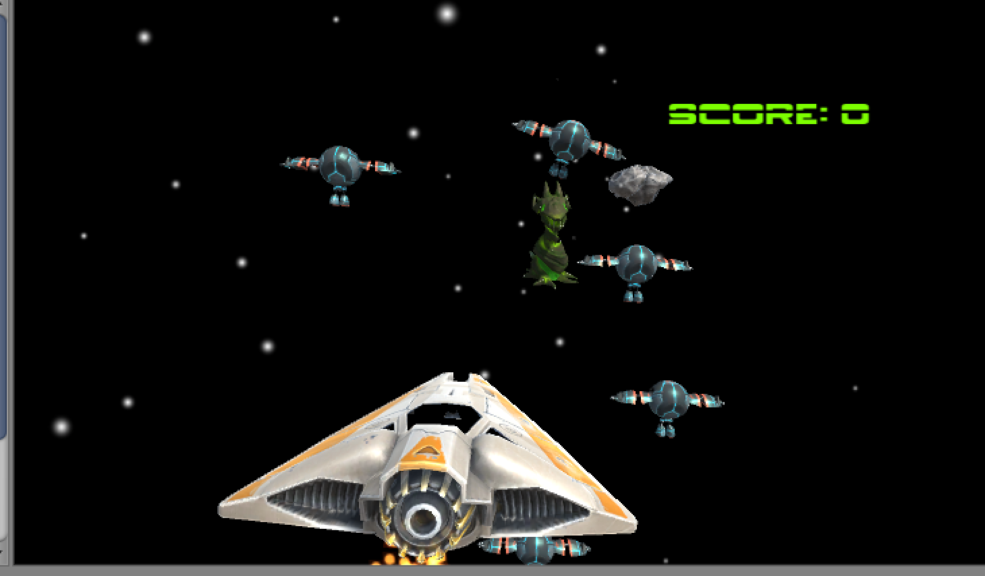

In this next screenshot, you can see a target being hit by a laser and exploding. The score has also increased since targets were hit, and a red X has appeared on the screen since a bad target has been hit.

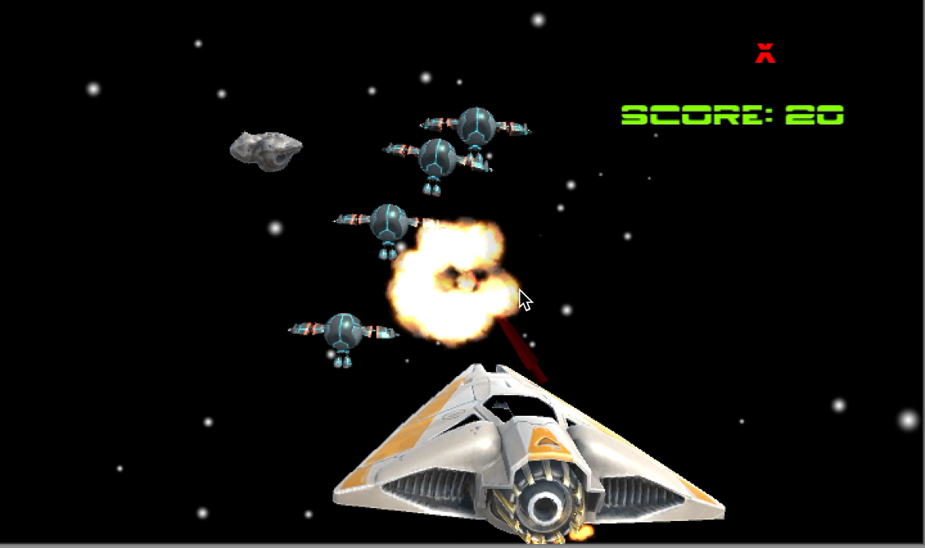

This last screenshot is of the game over screen. After the player has hit three asteroids, they are redirected to this screen where they can quit the game, and begin again if they so choose. Their final score is displayed at the top right hand corner as well.

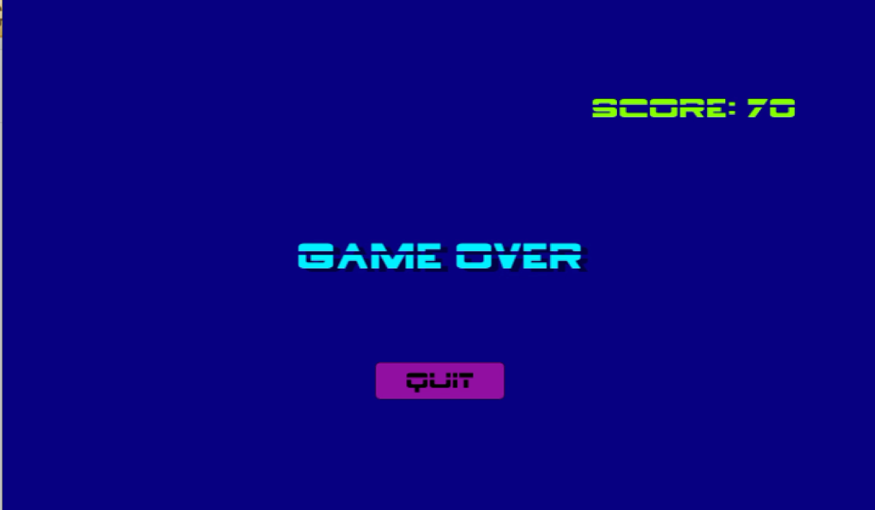

We took many of the concepts we have learned throughout our time in the Computer Graphics class such as the camera angle, shading on objects and characters, lighting, and mapping to also help with our shooting game. Although, we did use the assets provided for us in the Unity library, and didn’t create them from scratch like many of our fellow classmates did in Maya, Glu, or Glut. There were some things we were still able to manipulate and change ourselves to create the effects we wanted. We chose where the camera was located behind the space ship. We used lighting from above to cast shadows on the characters and space ship that was dimly light since space is dark. We were able to choose the patterns and colors of the characters and objects along with the shading to create a more unique game that was ours. Unity makes creating games easier and faster, and this is one of the main aspects that appealed to us in choosing to use it as our game engine.

There were many difficult issues and setbacks in the creation of “Galaxy Shooters” that given more time, or the decision to continue to further design the game we feel should be resolved for better usability, and to make the game seem more lifelike or 3D. We began this journey using a different game engine called OGRE, but this proved to be more difficult to learn, understand, and be able build a successful game in the given amount of time that was provided to finish our project. Our game engine quickly changed, and we decided to use Unity which has a much more simplistic usability. If we had more time we would have liked to stick with our original game engine, and tackled the task of learning and using OGRE. The particle system we used was chosen, because actually being able to simulate moving through space was found to be too difficult in the time span as well. We felt there were more important features and use of our time elsewhere in the design of our game. Another aspect that could have been improved upon is the space ship itself. We would have liked to be able to have the full range of motion including up and down, along with moving throughout space. The laser of the space ship was only able to be shot into the center of the screen while the space ship moves from left to right. Given move time we would have liked to be able to point the laser at any target in any direction during the game. The last issue we had trouble with was reloading the game level and adding a “new game” button on a start menu screen. All of these features would be able to make our game seem more 3D, really enhance the game to make it appeal more to gamers, and allow for better usability.

Given the short amount of time, and limitations of little knowledge of the game engine Unity, we feel we have created an overall aesthetically pleasing, easy to use game that is also fun to play. “Galaxy Shooters” may not be the most difficult game that competes with some of the more common games today like Call of Duty or World of Warcraft, but it has the simplistic, nostalgic gaming aspect of games like Pac Man and Asteroids. Our game is easy to use and fun for people of all ages, and varying degree of gaming ability and enjoyment. We ourselves are not huge gamers, and don’t play many video games. We wanted to create a game that would appeal to all how Pac Man is enjoyed by all. We hope you enjoy our game “Galaxy Shooters” as much as we do!

**Team Member Roles**

Kayla Schmitt: Kayla learned Unity and C#. Since it was difficult to find a solution to share code between Kayla’s Mac and Andrea’s Windows computer, Kayla decided to do all of the coding herself, with some help from Andrea.

Andrea McGovern: Andrea also learned Unity and C# and found the objects we used for the project. She also used her knowledge of the Unity, C#, and Galaxy Shooters to write the final paper for this project. She also helped Kayla with some of the details of the project.